**Final Project**

**Program Design and Methods**

Project Name: **TYPO**

Name: **Sri Kalyan Rohan**

Student ID: **2440090266**

Class: **L1BC**

**Project Specification**

The purpose of this project is to create a typing game that can help people measure and better their typing skills. It may seem simple at first but having a better typing skill can help do tasks with a higher efficiency as nowadays especially during this pandemic, everything is done online and through the computer. The user can choose how many sentences they want to type in and then they can start the game by typing in the input box. The sentences will be randomly generated from an external text file. On the bottom left of the screen, there will be a Typo rate which is the percentage of wrong character input that the user enters from the entire character input. For example, if there are 100 characters and the wrong input made is 2 then the typo rate will show 2 percent. At the end of the game, the user will be brought to a game over window where it shows the statistics of the user from the typo rate, accuracy, words per minute, number of characters and time taken. Based on the statistics, the user will be given a rank accordingly and it will be indicated with a gem. Even though, typing games are fairly simple, I think that nowadays games that are minimalistic and are user friendly can last for quite some time and not only that, you also get to better your typing skills!

**Input**

1. User’s keystroke when typing in the sentences.
2. Number of sentences

**Output**

1. Accuracy
2. Words typed per minute
3. Number of characters typed
4. Typo Rate
5. Rank
6. Time taken

**Solution Design**

1. Main Menu
2. How to play
3. Setup (How many sentences)
4. Main Game
5. Results

**Main Menu**

The main menu is pretty straight forward. You can use it to navigate yourself through the game like going to the How to Play window to look at how the game is played or you can go to the Instruction window to setup and play the game.

**How to Play**

Another straight forward window that shows the user how to play the game. It also shows the guide of the ranks or tiers that the user can get as a result.

**Setup**

This window sets up the game of the user by asking the user for input for the number of sentences that the user wants to play with.

**Main Game**

This window is where all of the game play happen. The user can track their typo rate through the bottom left of their screen. This window starts with a guide text on how the user can start playing the game. The user then starts typing the sentences in the input box

**Results**

This window will show the user their statistics. It shows the accuracy, speed, time taken, number of characters and the rate of typo of the user. It also shows which tier or rank the user ends up with.

**Implementation and explanation of code**

For this project, I’m only using two modules which are the arcade module and the random module. There are 6 classes that I created in this project. 5 of them are used for showing the different views or windows of the game and the last 1 is for the GUI element. For the view classes (Main Menu Class, How to Play class, Game View class, Game Over class and Setup View class) I am inheriting from the arcade class module called ac.View(). This view basically allows me to have multiple views or windows as I can easily navigate through them. For the UI class (Button class), I will be inheriting from the arcade GUI class module called ac.gui.UIFlatButton(). This class already is a built in button class that I can use to create my buttons later on.

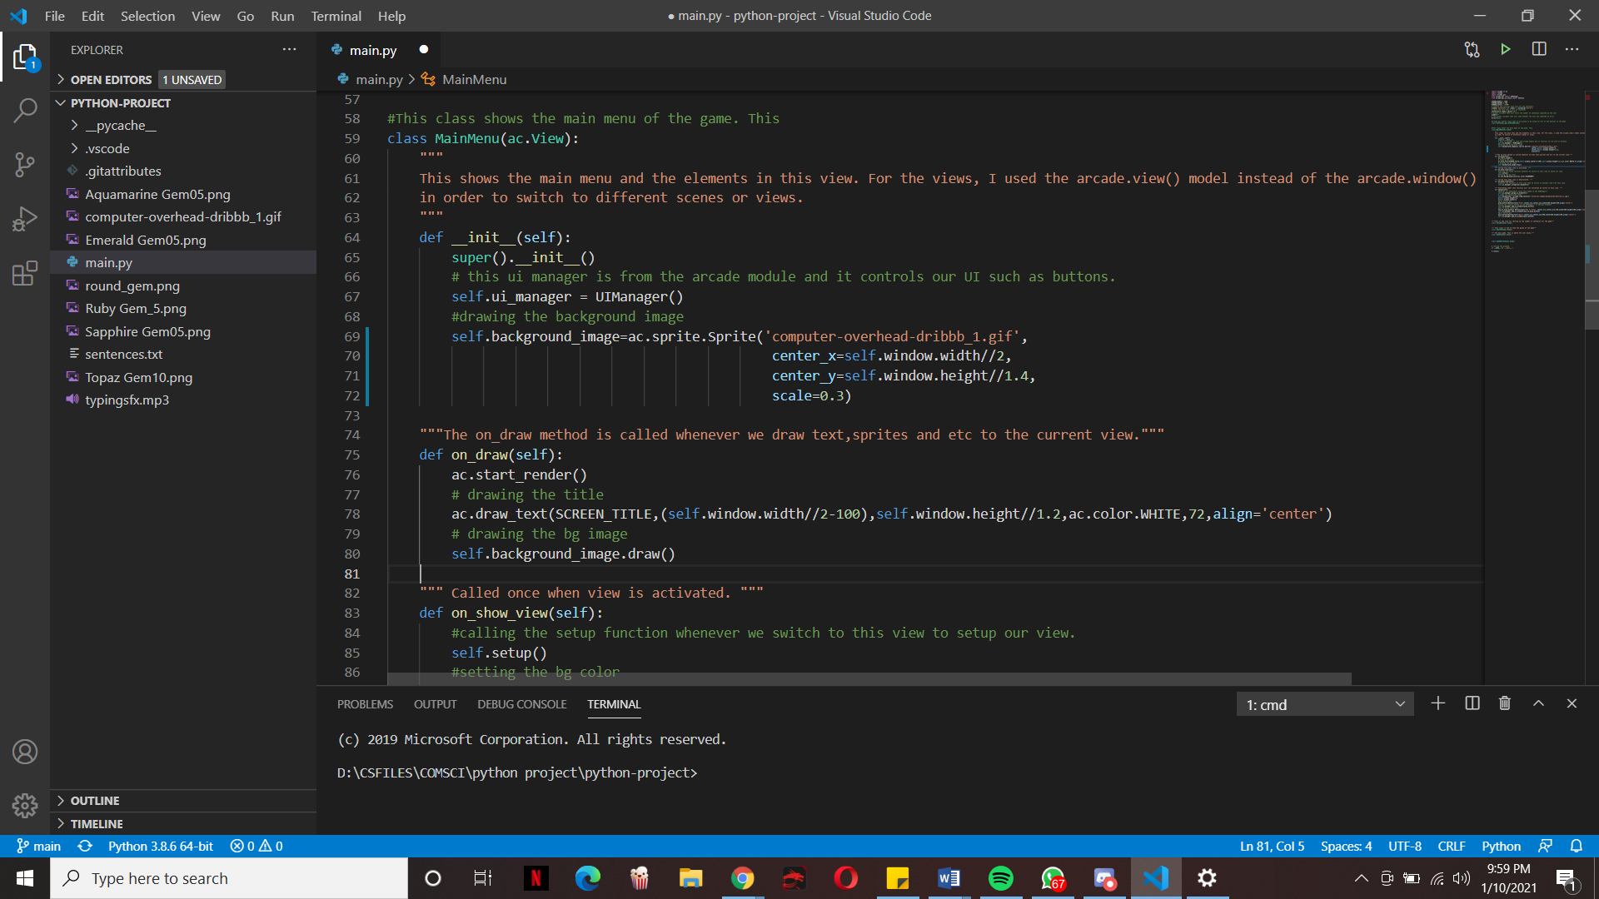**Main Menu Class**

In the init method is where I initialize the attributes that I are going to use to make the view. All throughout the proejct self.ui_manager will always be equal to UIManager(). This UIManager() comes from the arcade module and it is used to manage the UI elements of the view such as buttons. I also initialize the background image by using the built in sprite class from the arcade module, I can load the image sprite.

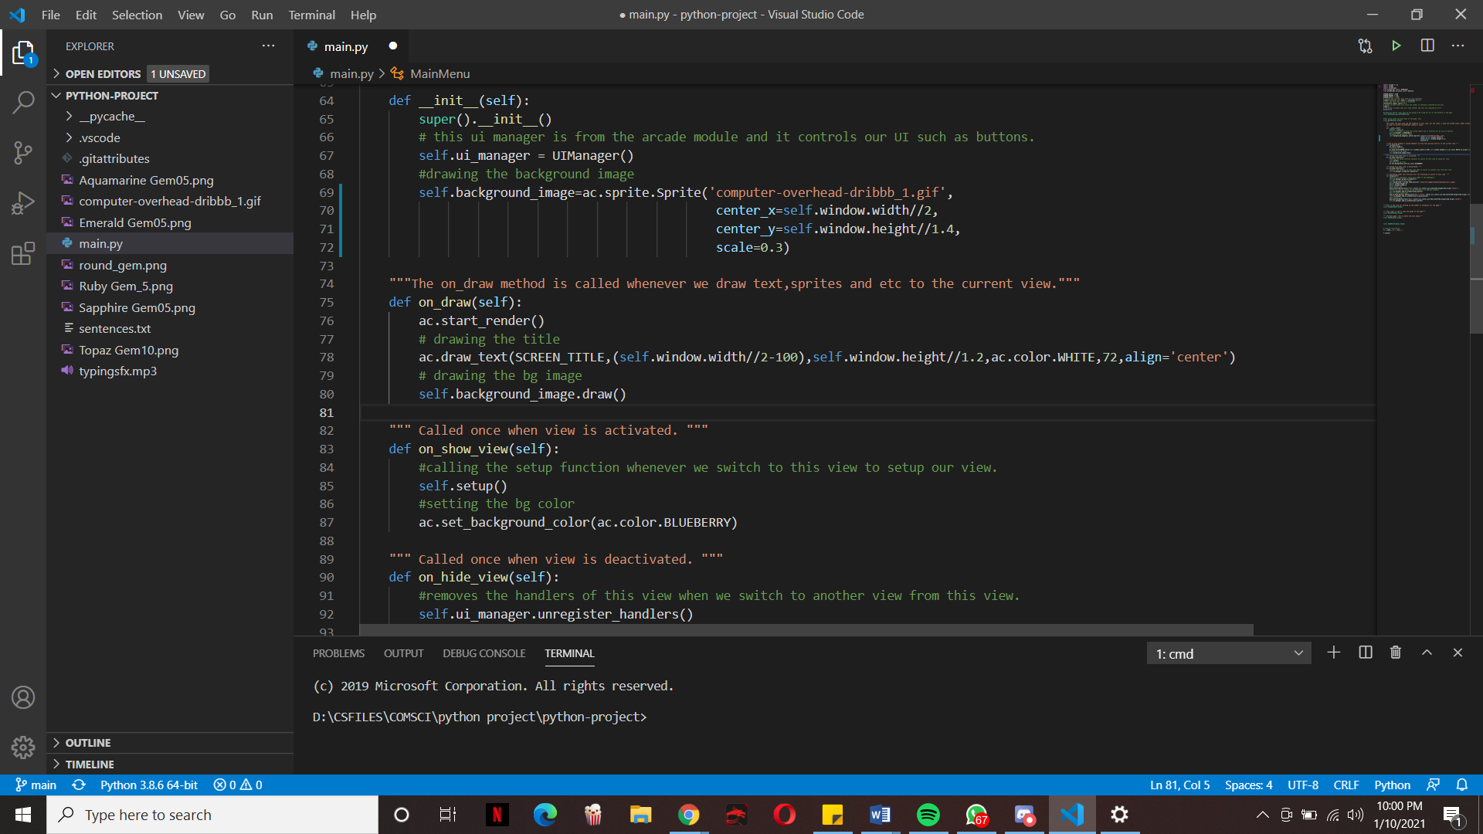

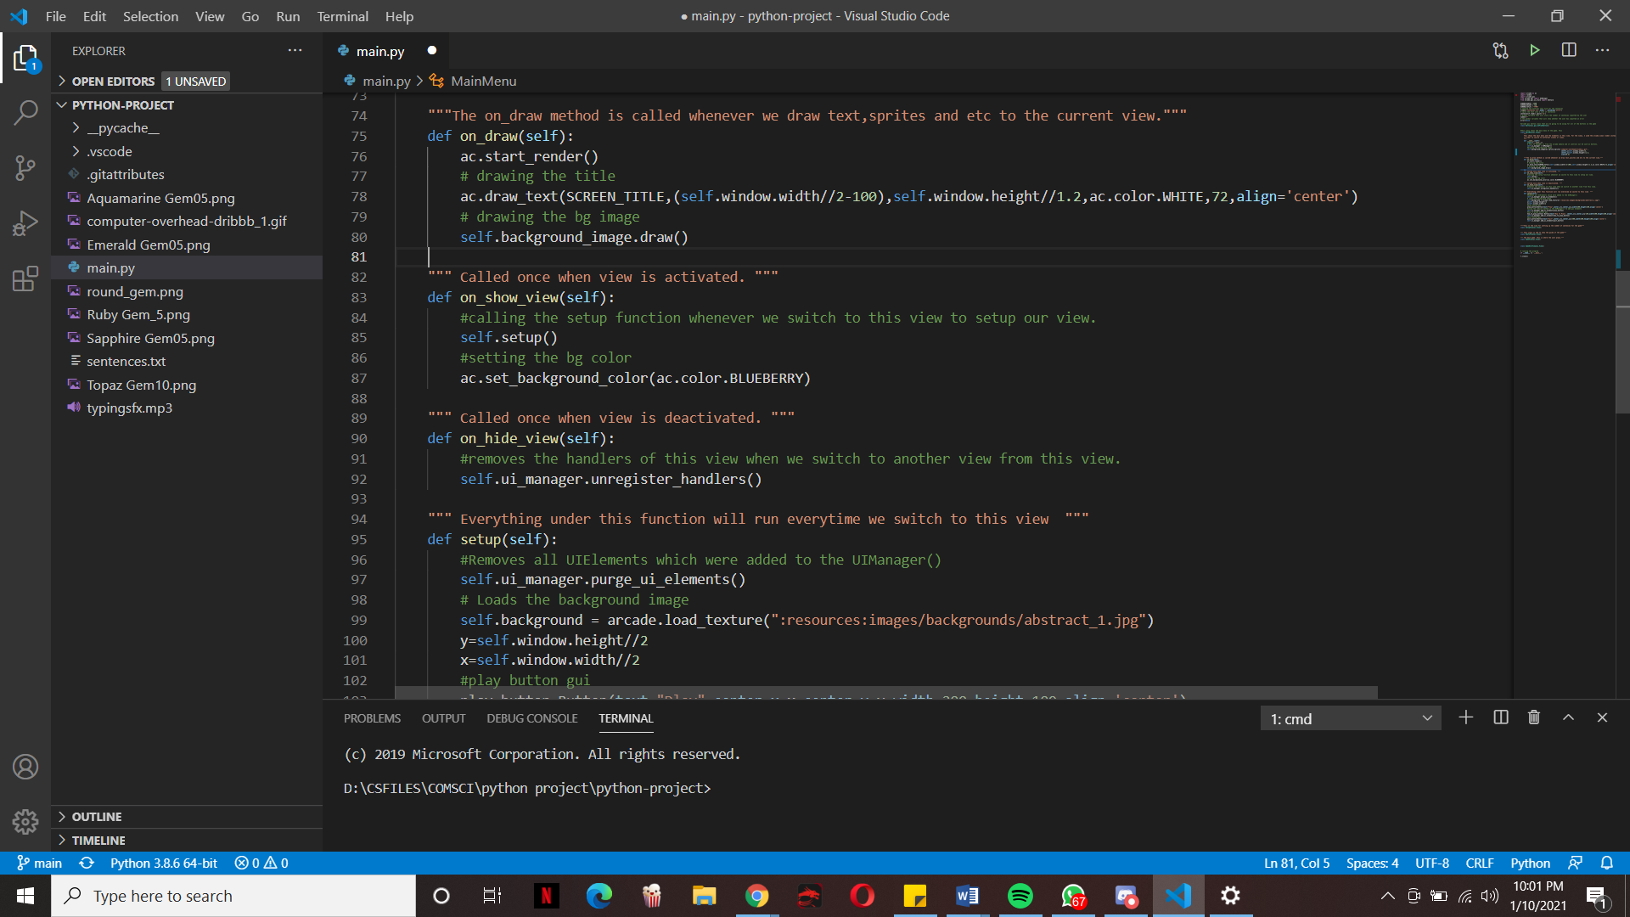The on_draw method is used to draw the elements of the View. The start render function is called to render the elements that I want to draw. The draw_text function is also called to draw text to the view. I also use the draw sprite method the draw the background_image sprite that I intialzed earlier.

The on_show_view and on_hide_view method is called when I change to and from the view respectively. For the on_show_view method, whenever I switch to the view, I want to call the setup() method to setup the view instantly. I also set the background color here. For the on_hide_view(), I use the UIManager() to unregister the handlers of the current view, so that the gui elements from different views don’t overlap with each other.

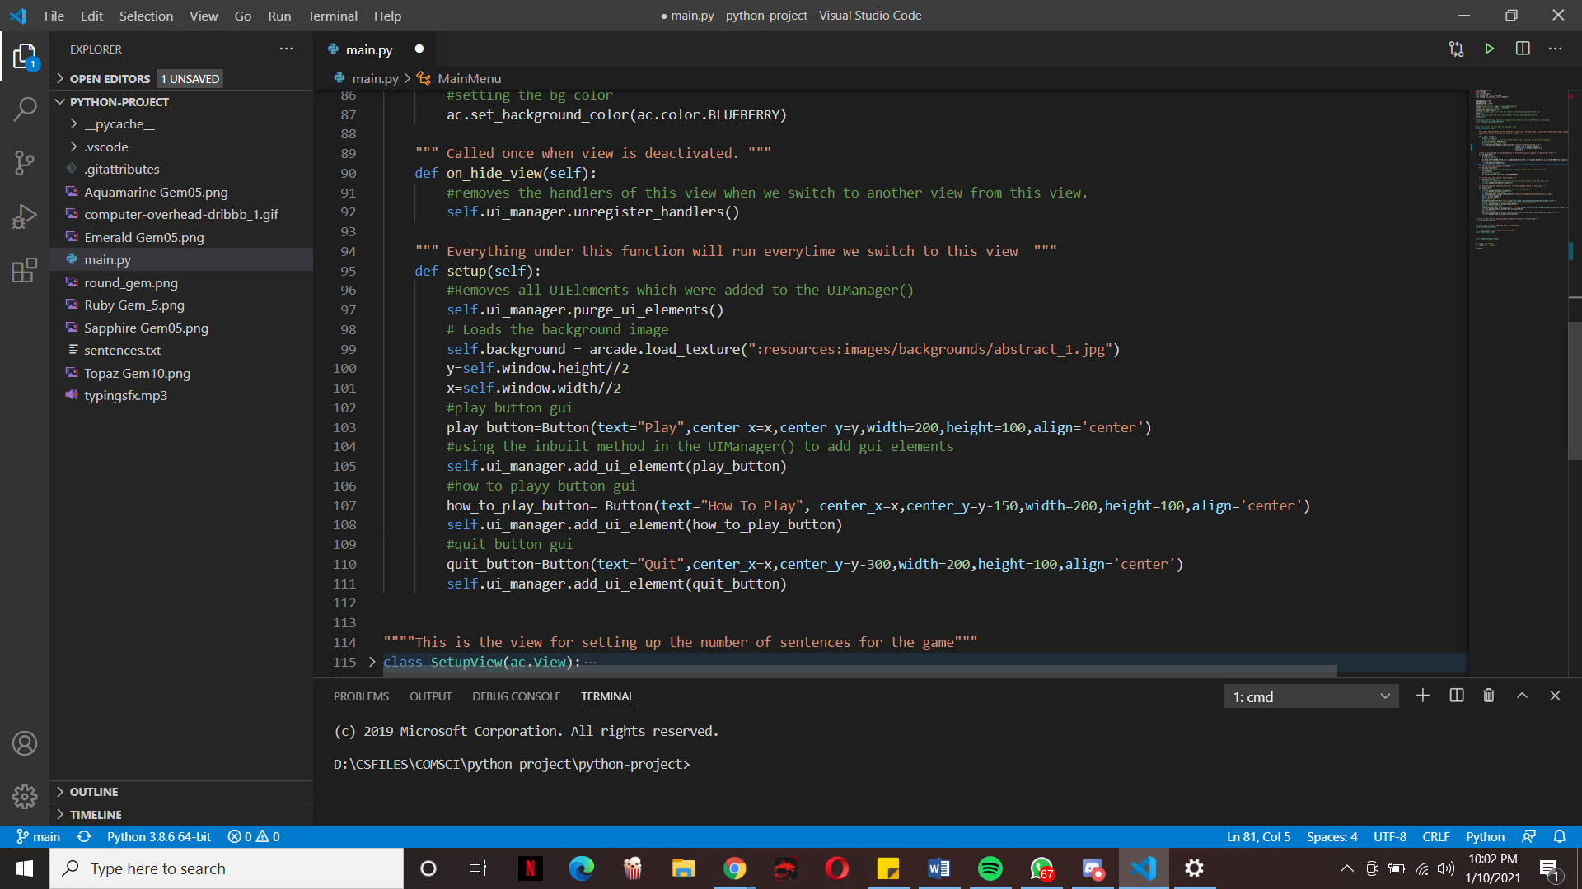

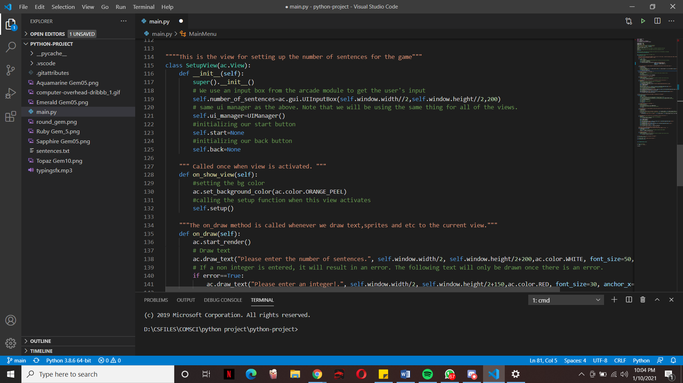The setup function is always called first whenever I change to the view thanks to the on_show_view() function. The first thing I did was to purge the UI elements. In other words I are removing the UI elements that Ire added to the UI manager. I then load the background image by using the load_texture method. I set half the window height to y and half the window width to x so that it will be easier to adjust positions of elements later on. I then created the Play, how to play and quit button by using the Button class that I will be discussing later on. I then use the UI manager to add these buttons into the view by using the add_ui_element() method.

The initializer for the Setup view. Here I used the same name for the UI Manager and basically for all the views. I set the self.start and self.back as None as I am going to be creating the start and back buttons using those respectively.

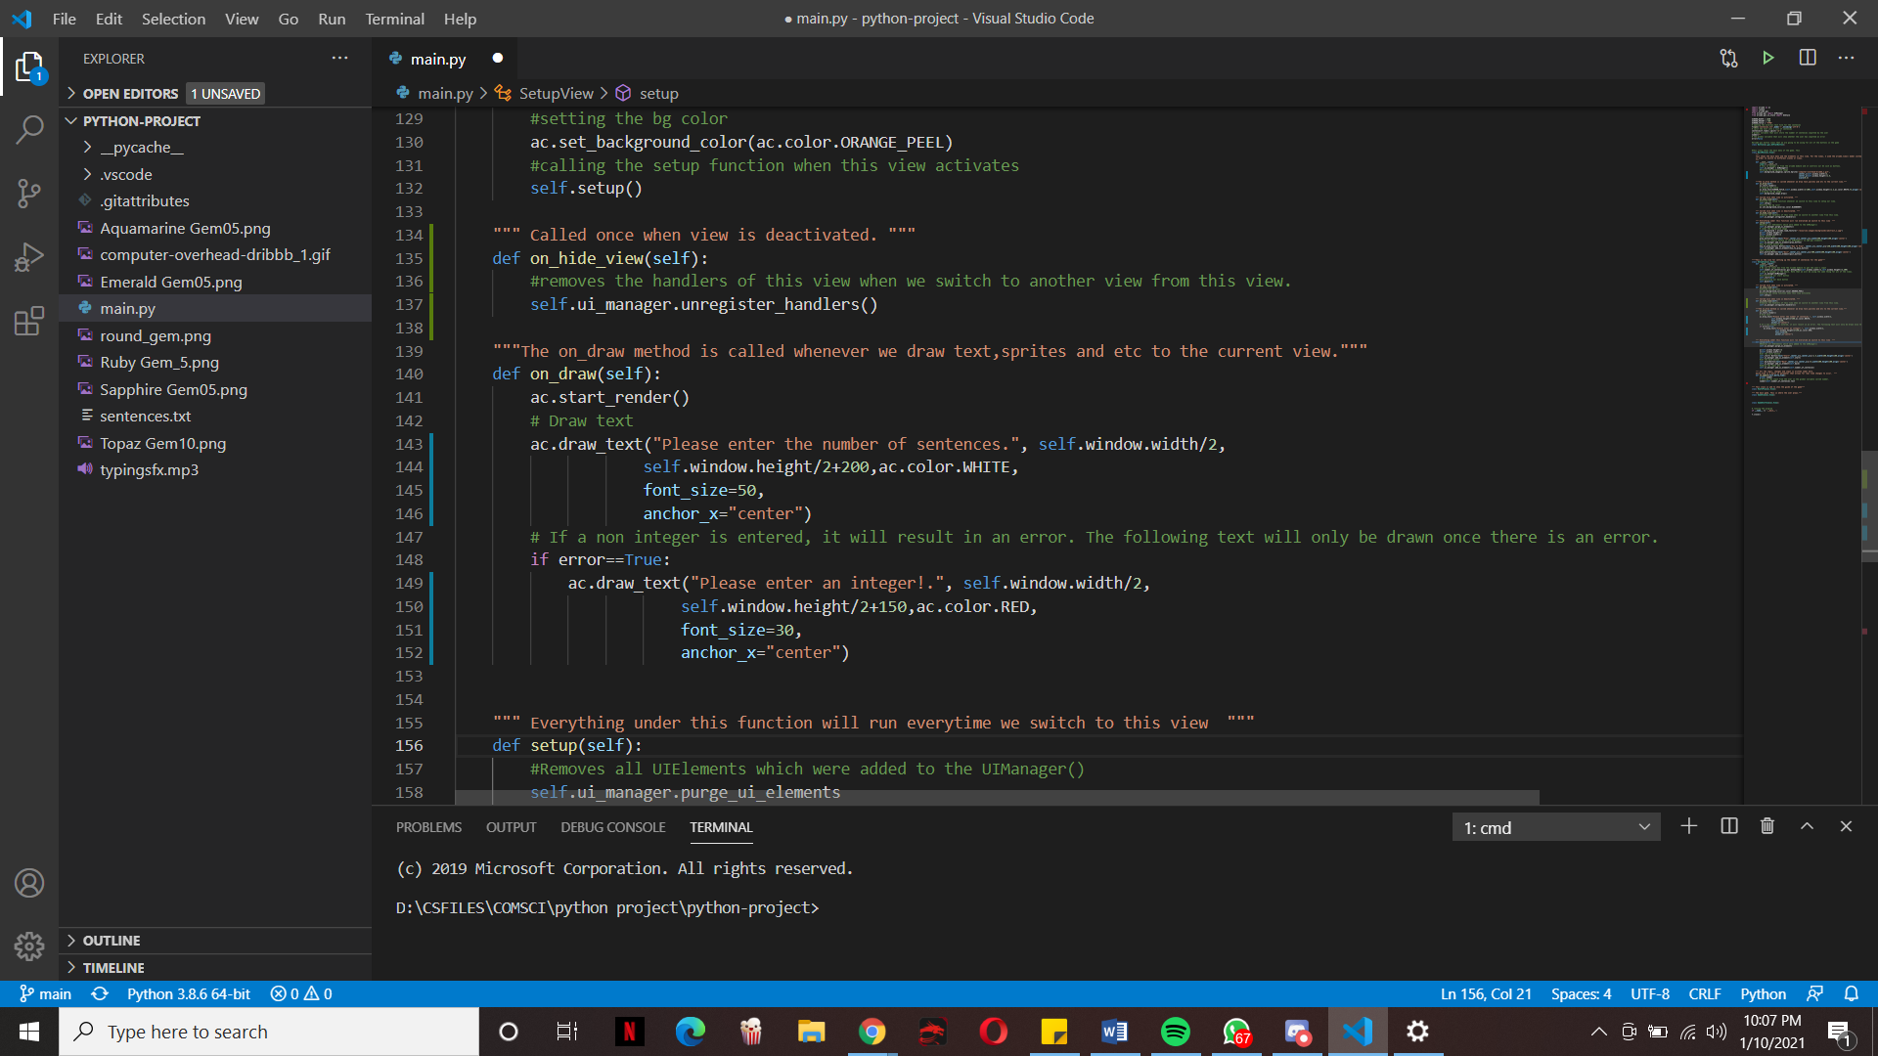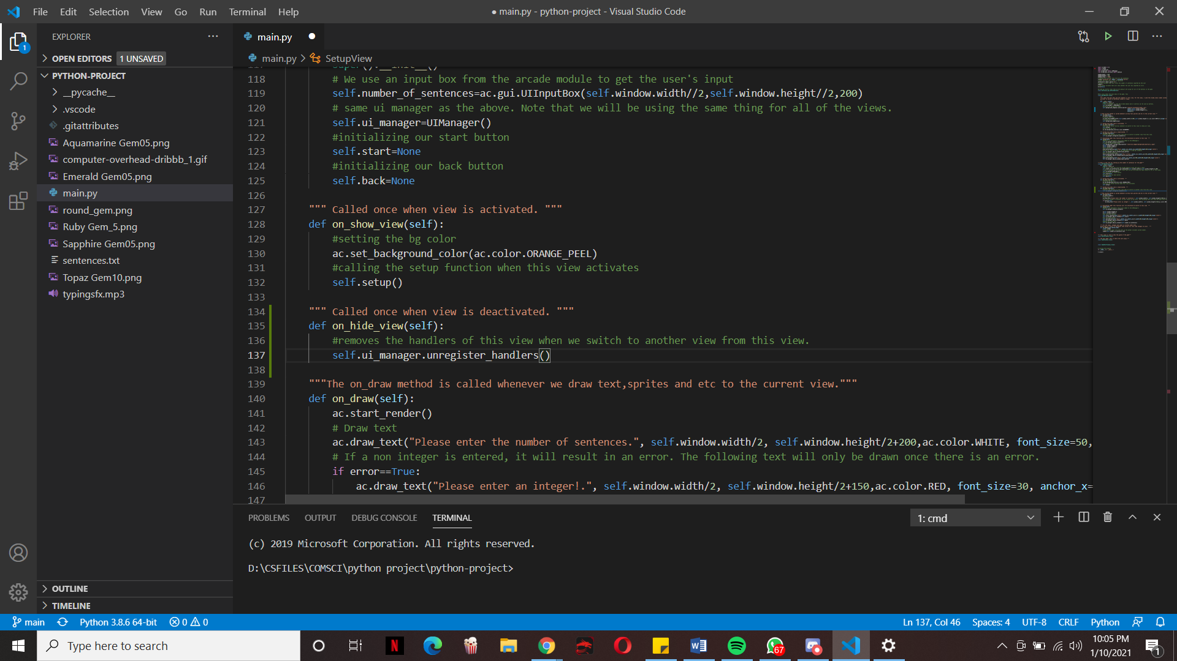Same on_show_view and on_hide_view function as the previous view.

On_draw function for the Setup View. Here I drew the necessary text using the draw_text method. The second draw_text method is under a condition and that condition is if the global variable error is equal to true. I did this so that whenever the user inputs a non-integer to the number of sentences that they want, this text will be drawn to show that the users input is invalid.

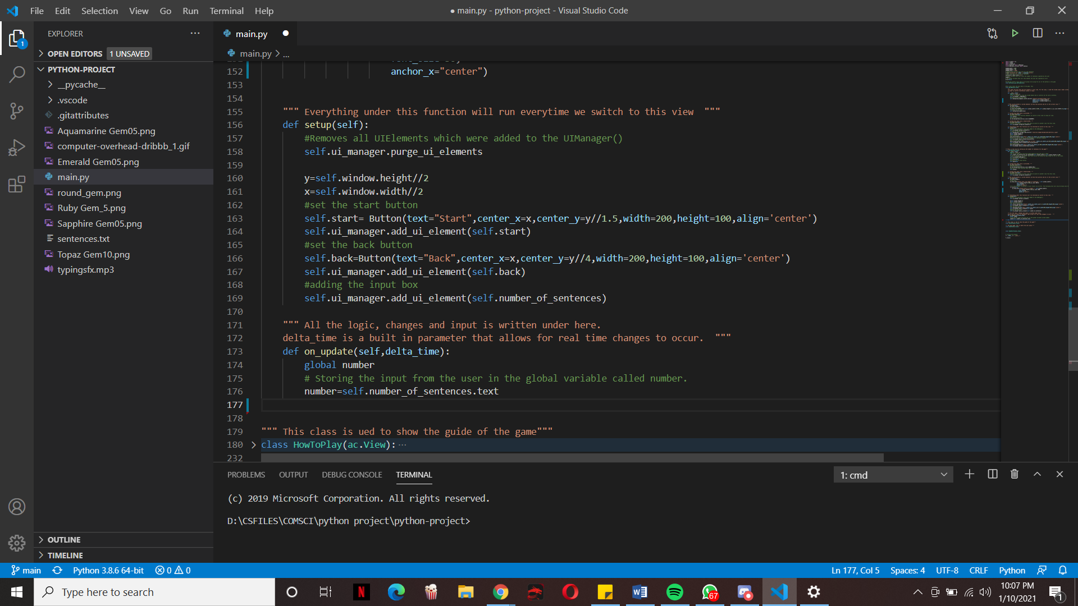

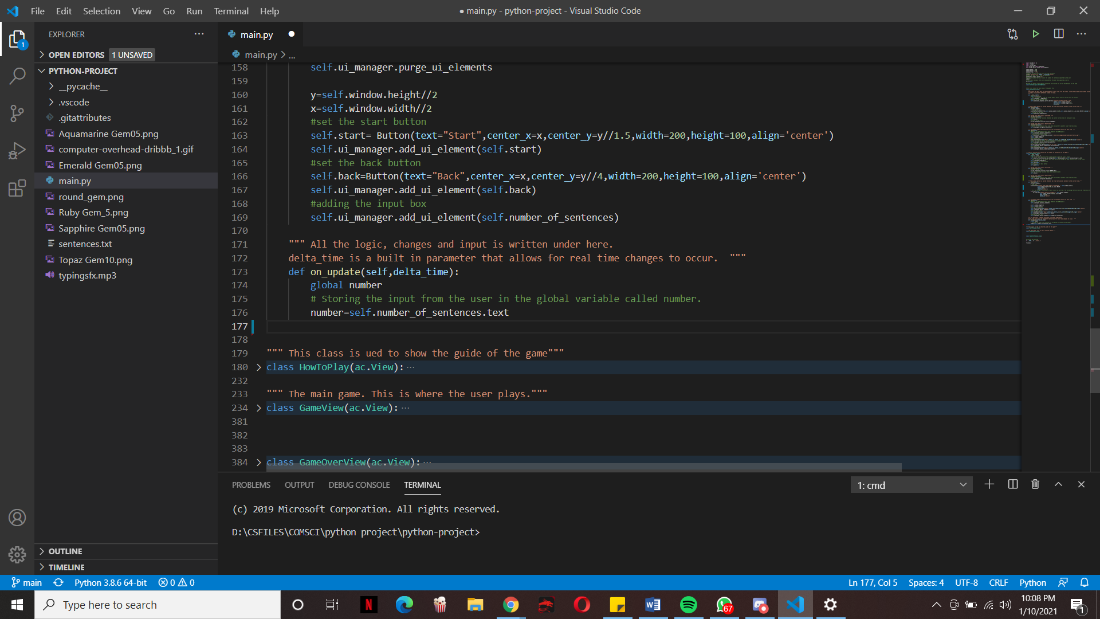The setup() method for the Setup view. For the setup method of all views, you will notice that all of the gui elements such as the button are added here. I will not elaborate much as I have elaborated already on the previous setup() method as I feel like it will be redundant.

The on_update function takes in one parameter and that is delta_time. Delta_time is essentially real time and this allows us to create changes and interact with the view. This is why all of the logic and user interface in the view is under this. For this on_update function I are just setting the input of the number of sentences from the user equal to the global variable “number”. This global variable will be the number of sentences in the game view later on.

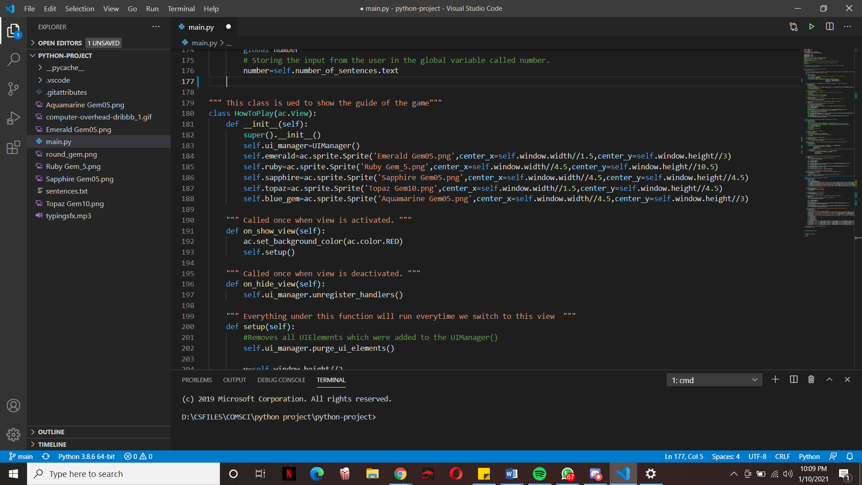

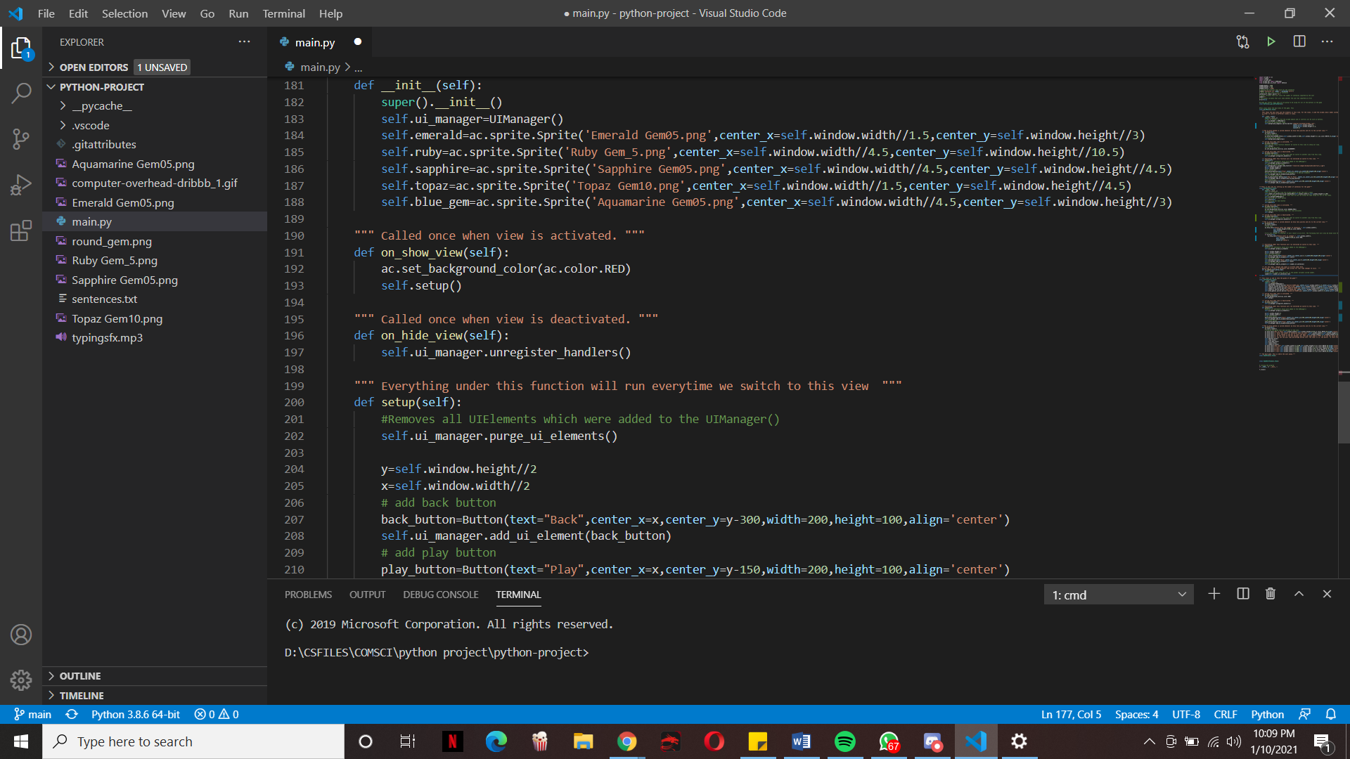Initializer for the How To Play class(). Here I load the image sprites for the ranks using the Sprite method that is built into arcade.

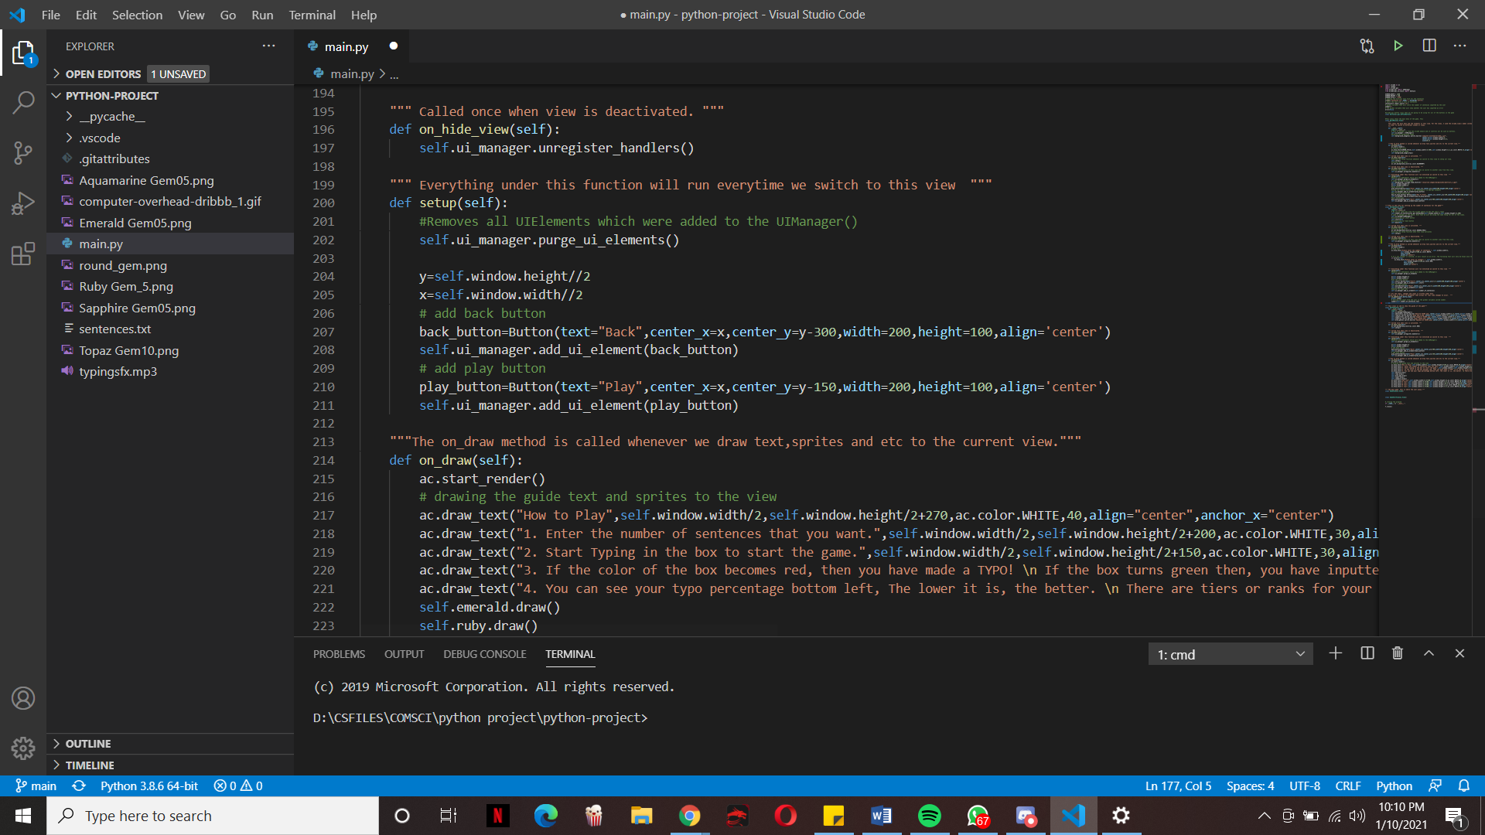On_show_view() and on_hide_view() for the how to play class. The same as before but only changing the color to Red.

Setup() method for the How to Play view. Here I added the play and back button using the same Button class that allows I to create an interactive button gui.

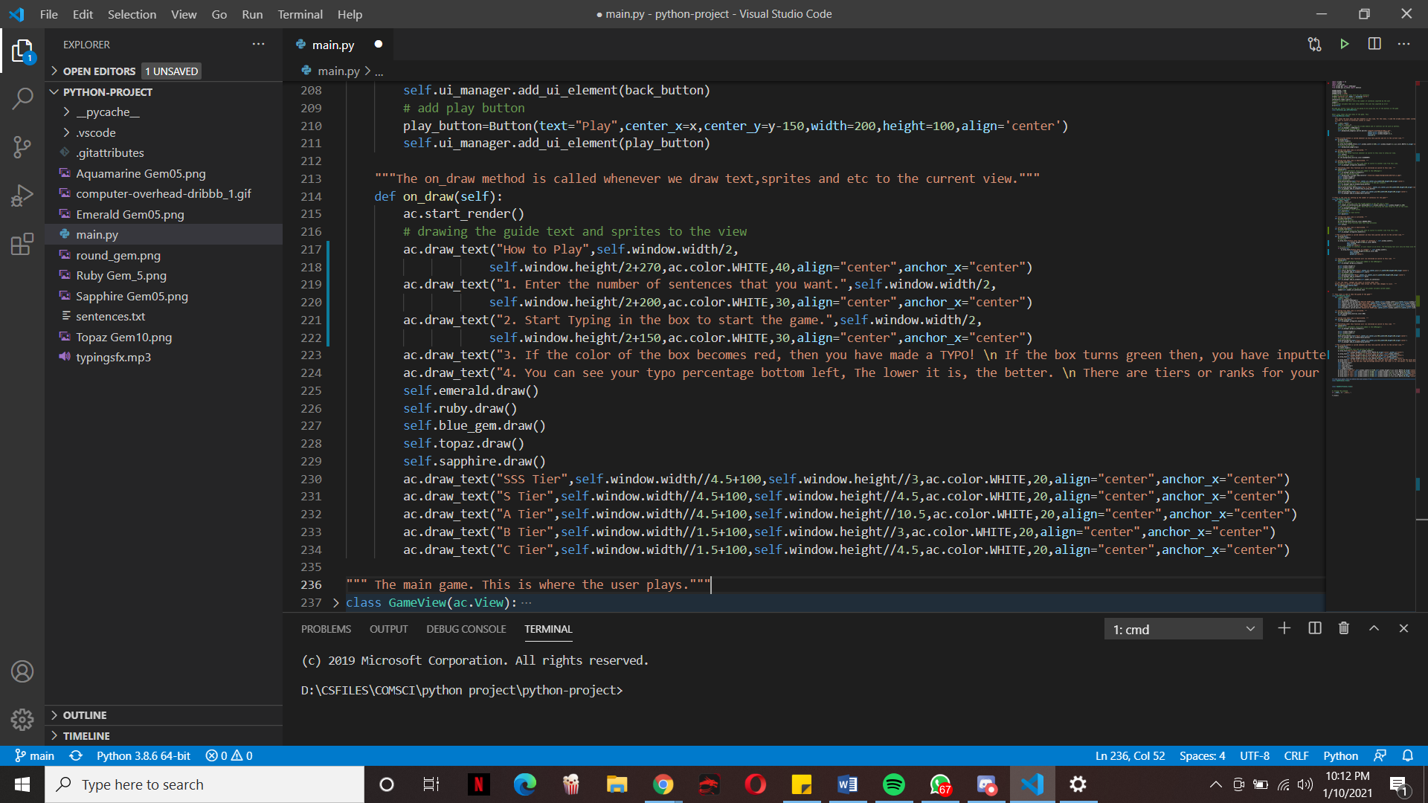

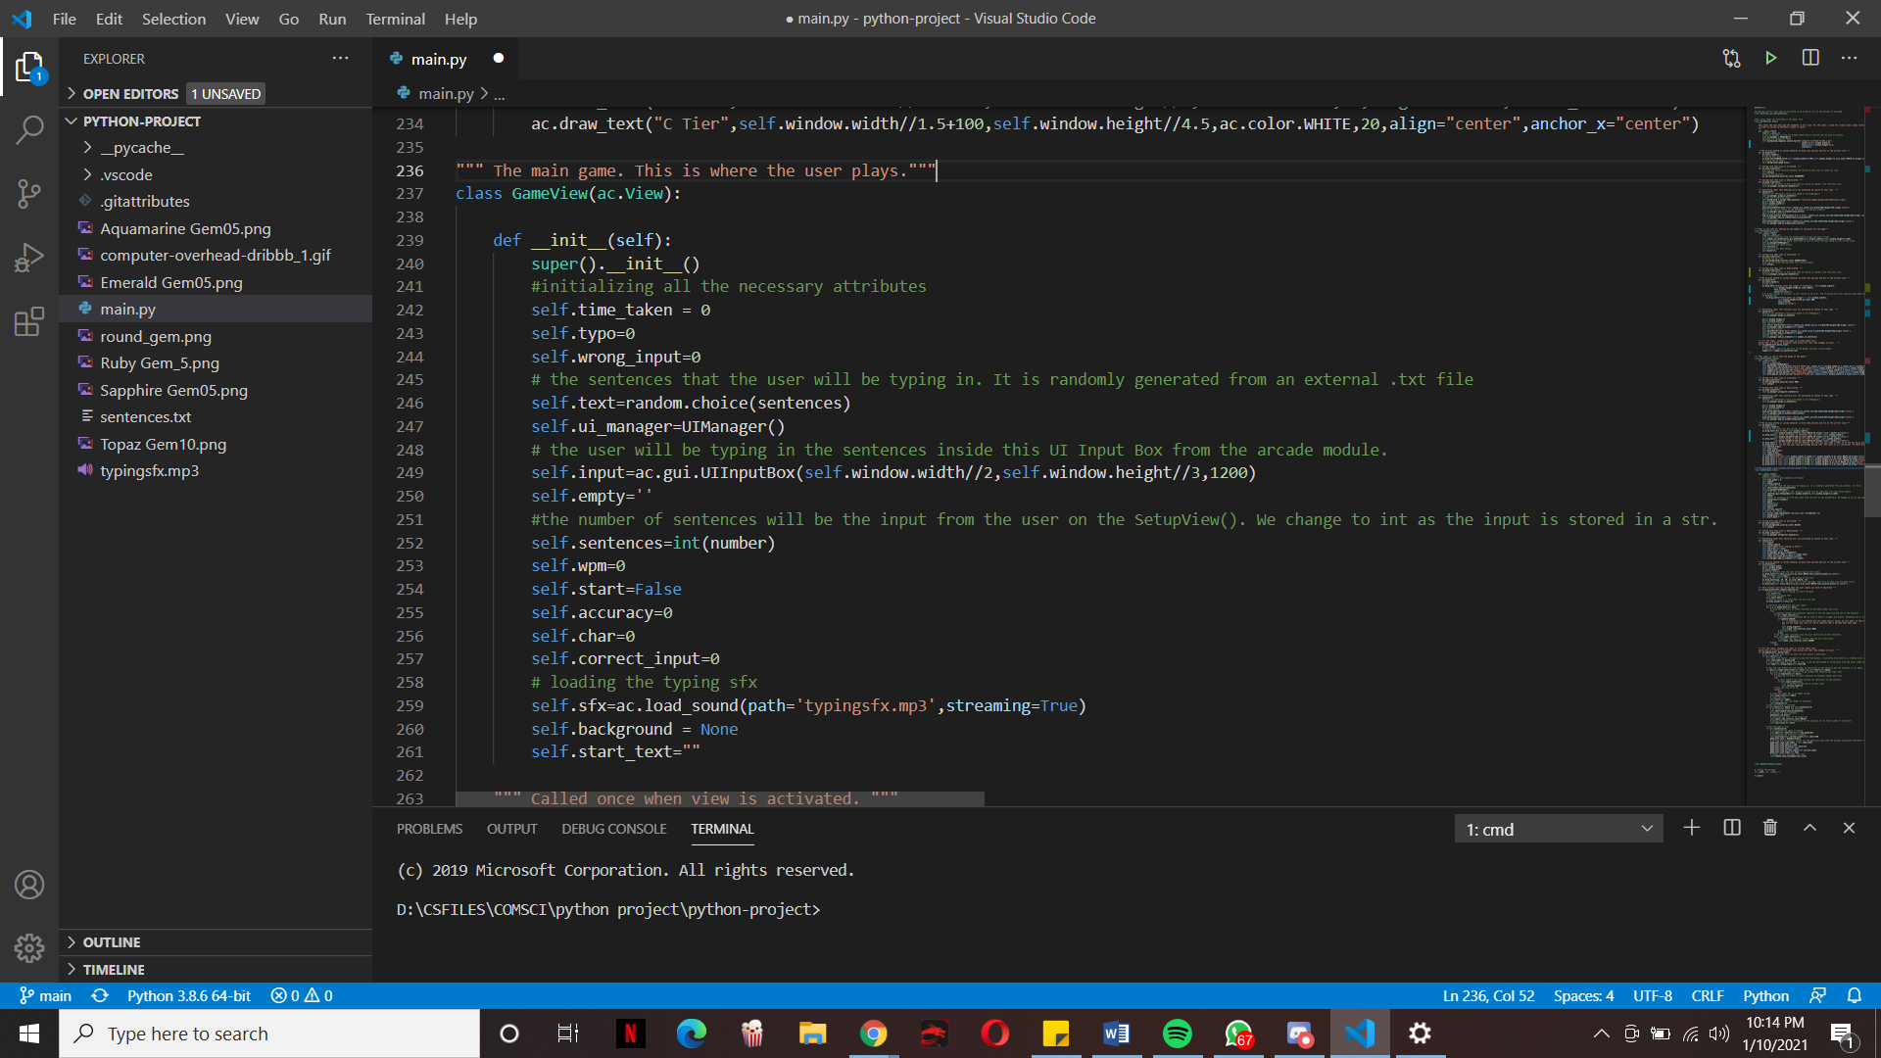The on_draw function for the How to Play view. Here is where I draw all the necessary sprites and text for the player guide. This whole view is essentially to give the player guidance and help on how to play the game.

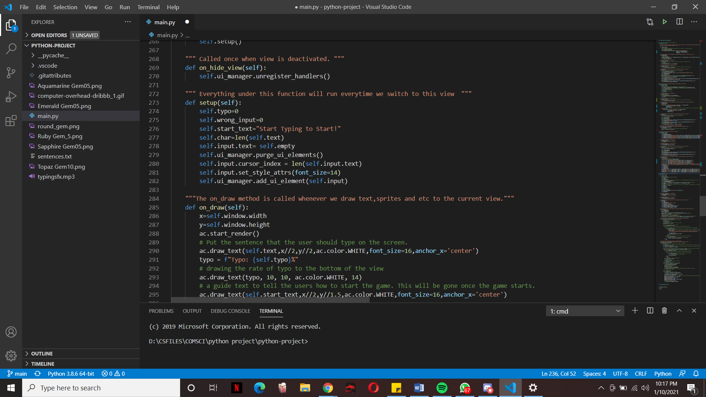This view is where the main game happens. Here I intialize the attributes for the statistics of the player. Such attributes are everything that is set to zero. I also initialize the user input as the same input box from the arcade module. I also intialize the sentence that the user will type using the ranom.choice() from the random module. I also initialize the number of sentences as the global varibale “number” and since this global variable is a string because of the input from the Setup View, I use the in() to change it to an integer. I also loaded the sfx sound here. I set the self.start to False as the game don’t start instantly.

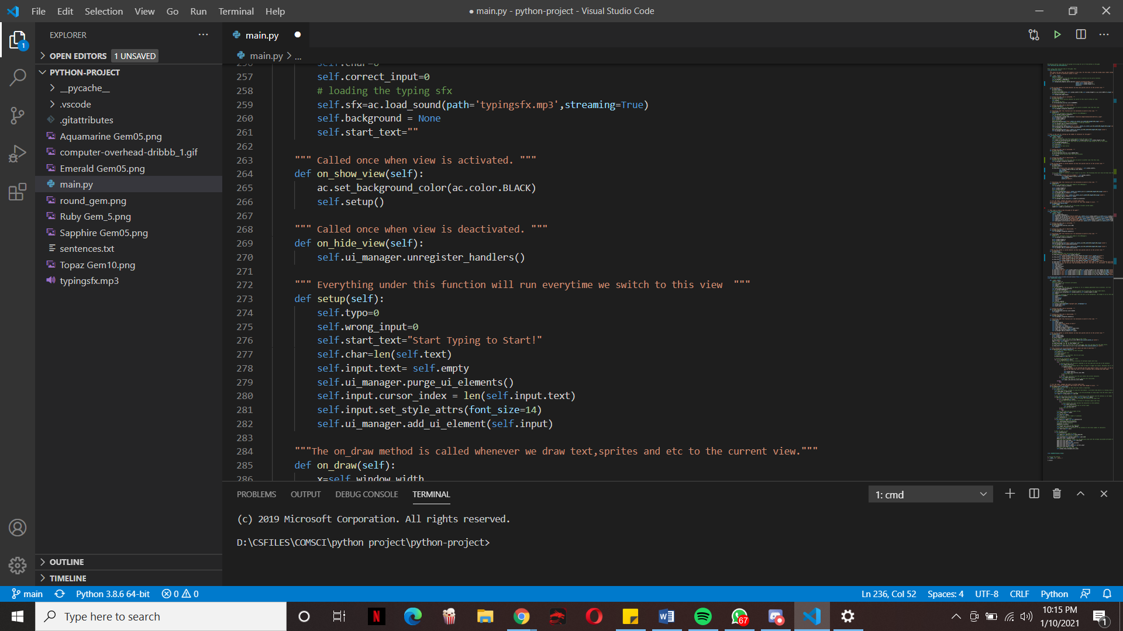Setup() method for the game view.

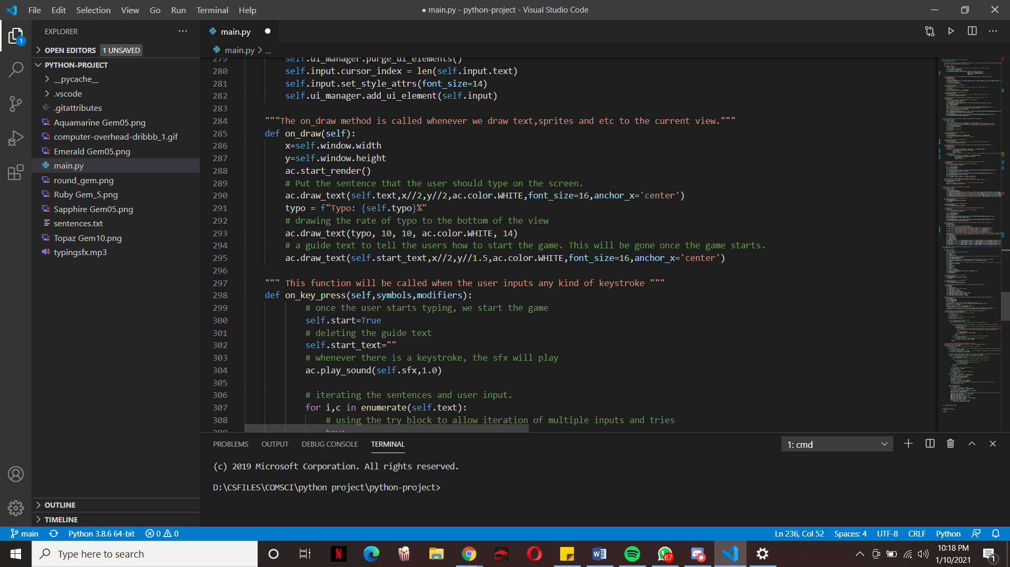On_show_view and on_hide_view for the game view but this time the color is BLACK

On_draw method() for the game View that draws all the necessary elements.

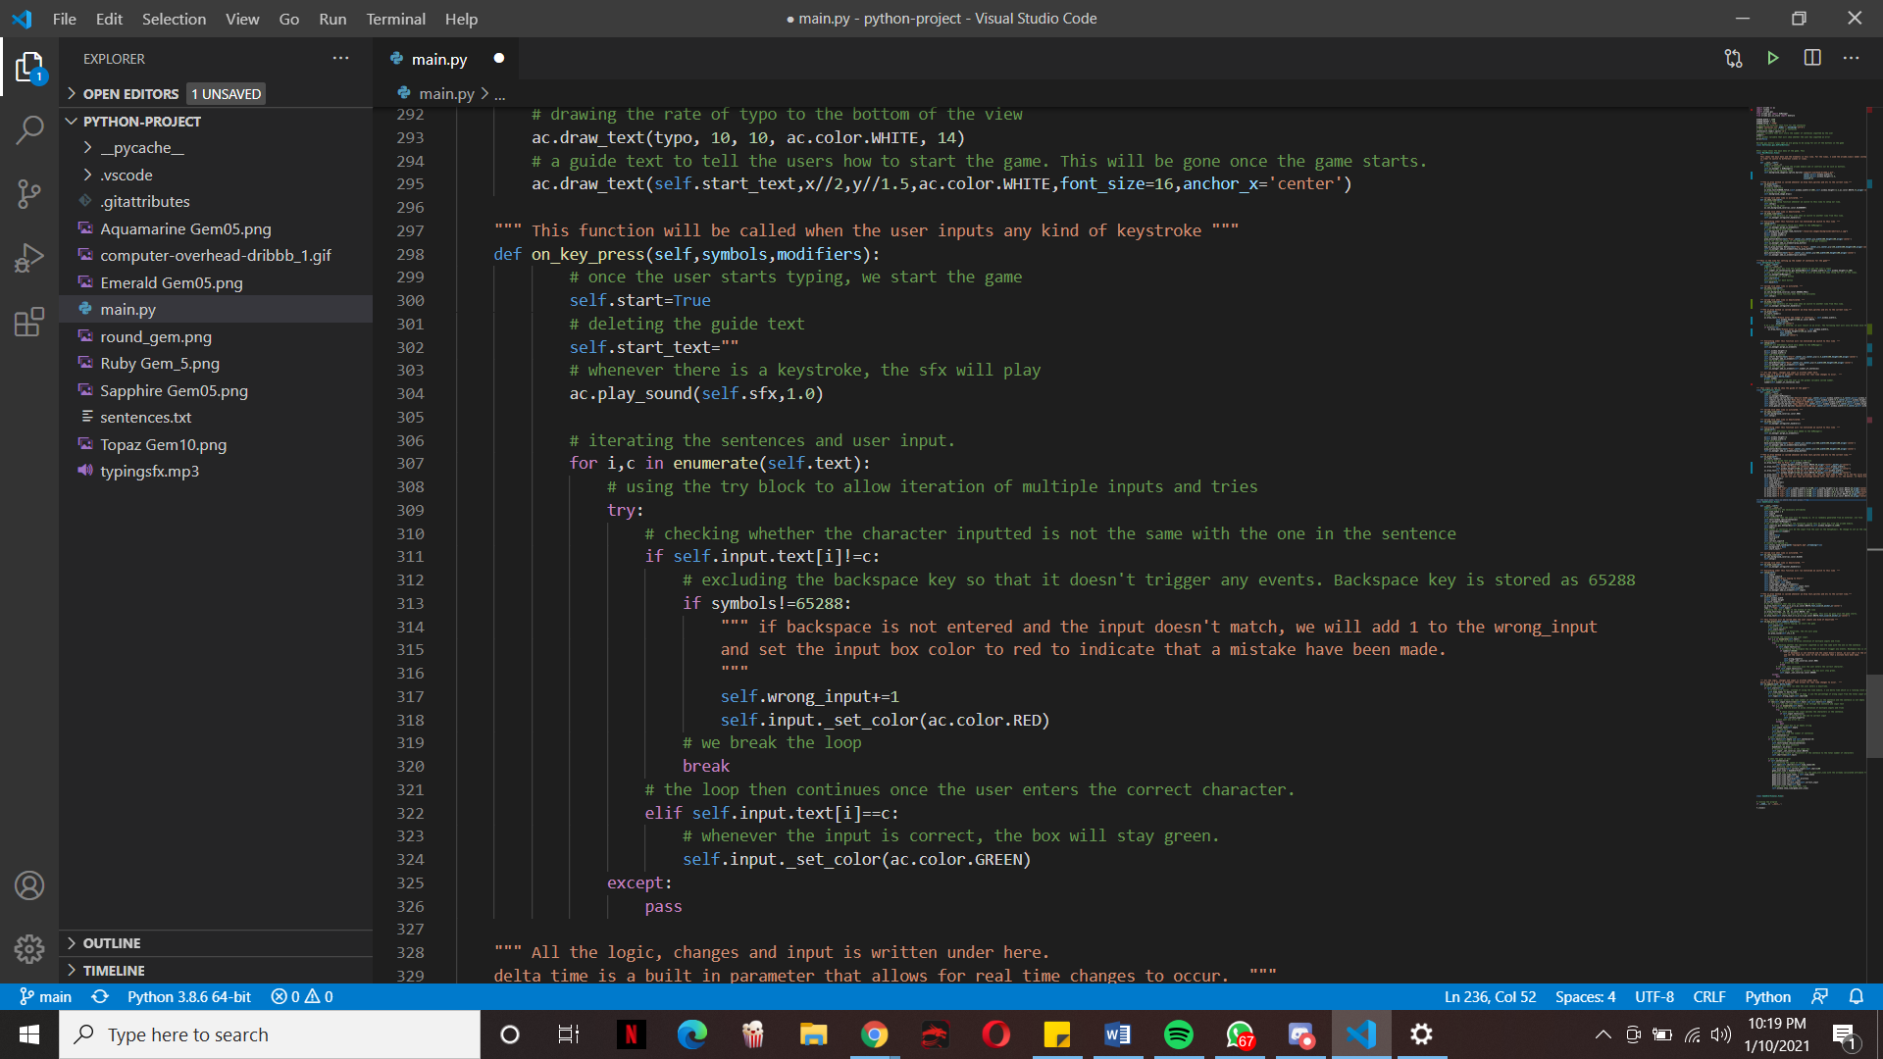The on_key_press() is called whenever the user enters a key_stroke. It is an built in function from the arcade module. Under this function is where I set the self.start= True and this means that when the user starts typing, the game starts. I also play the sfx sound here so that whenever the user types, the sound plays. The for loop here essentially checks whether the user enters the correct input and it changes the input box color to green if it is correct and changes the color to red if it is wrong.

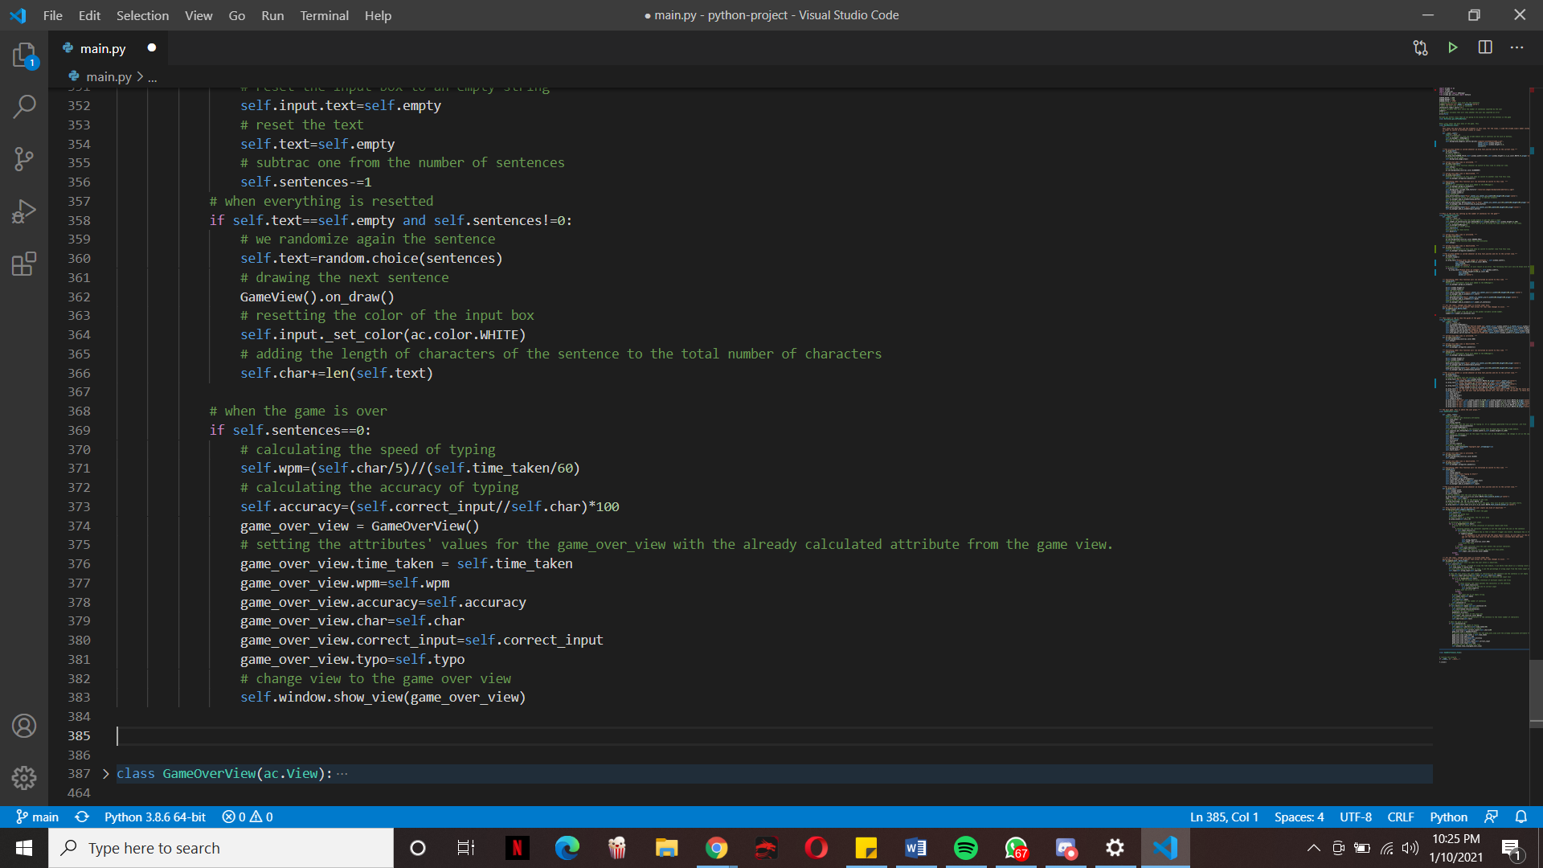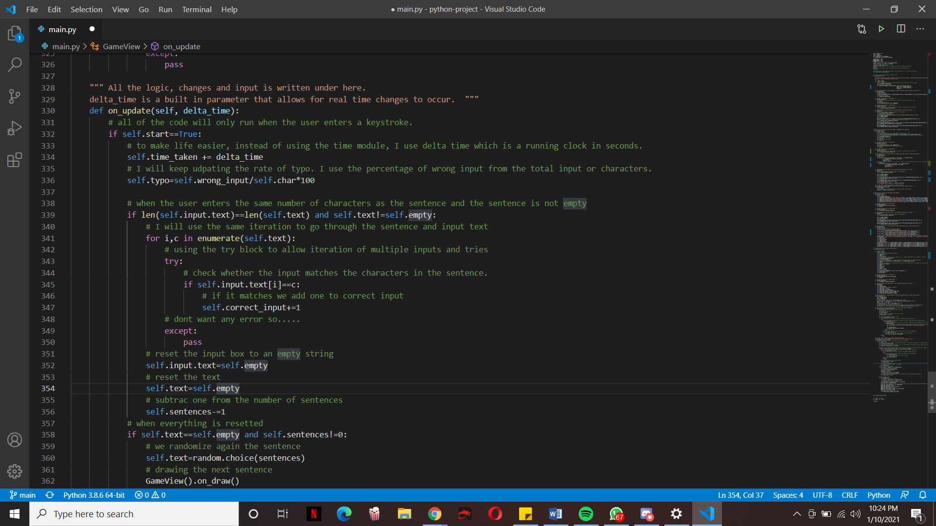

On_update method for the Game view()

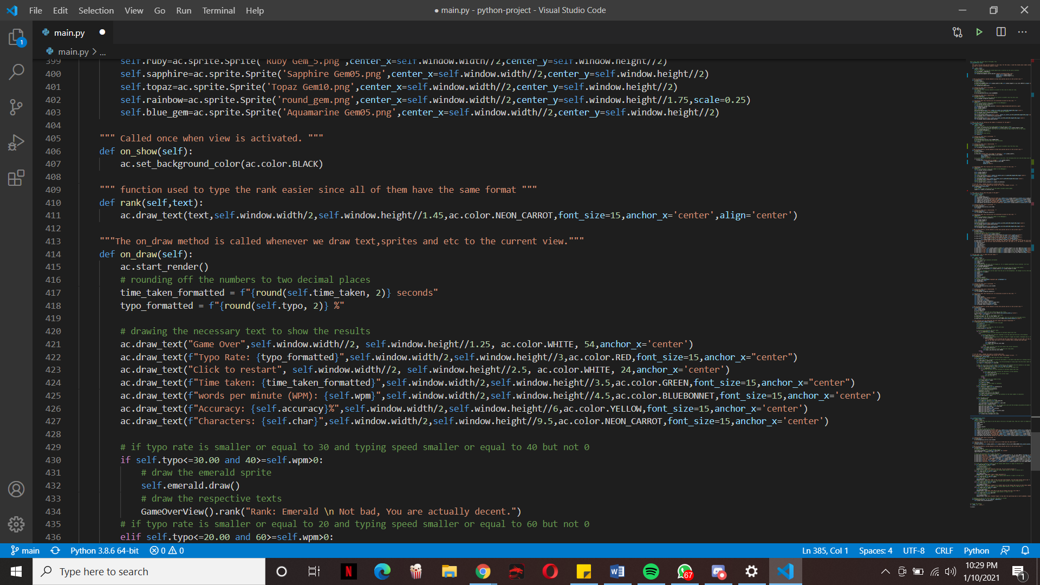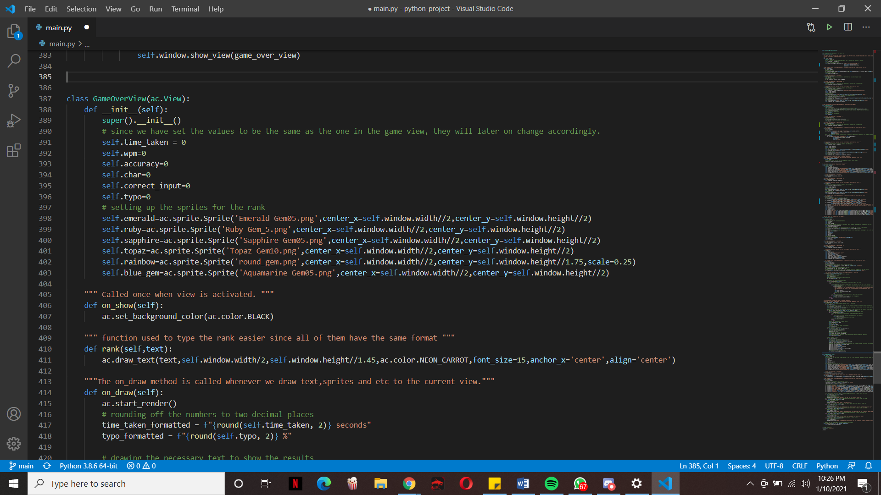

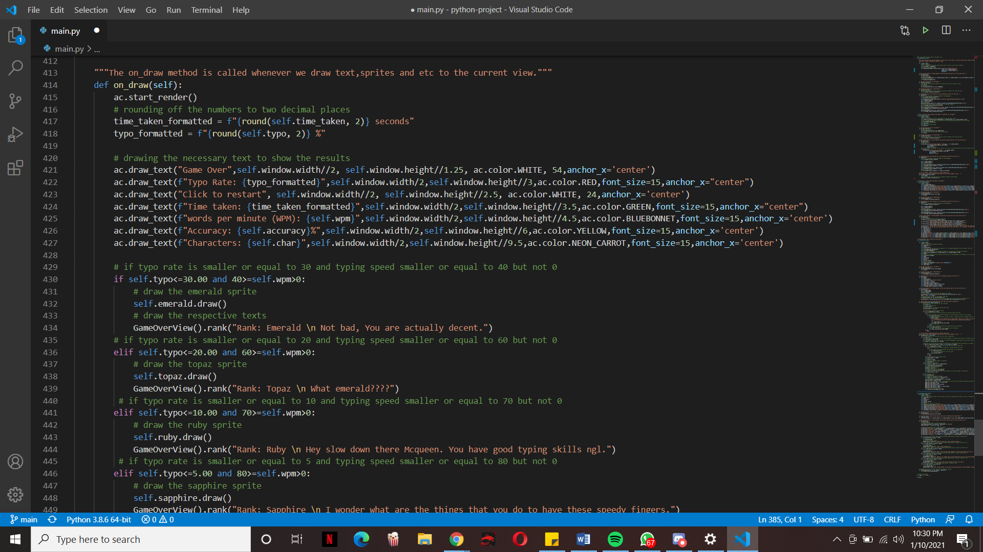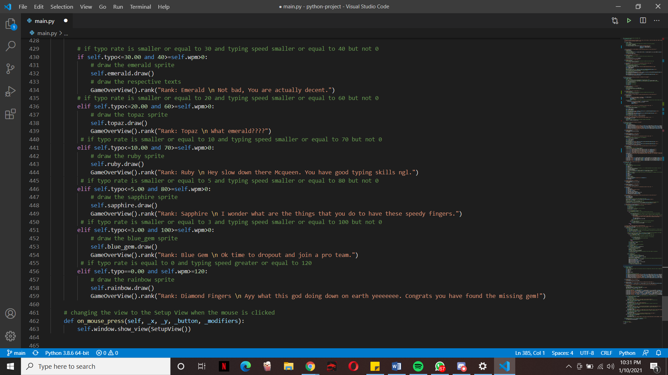

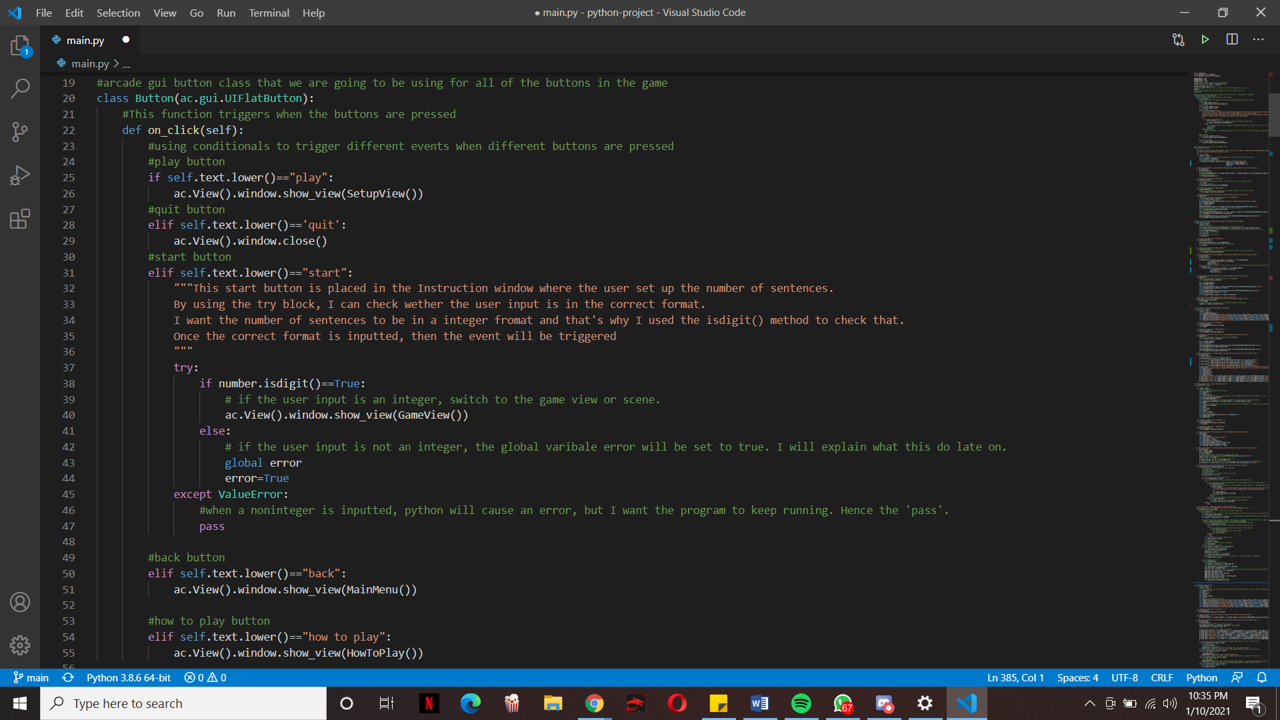

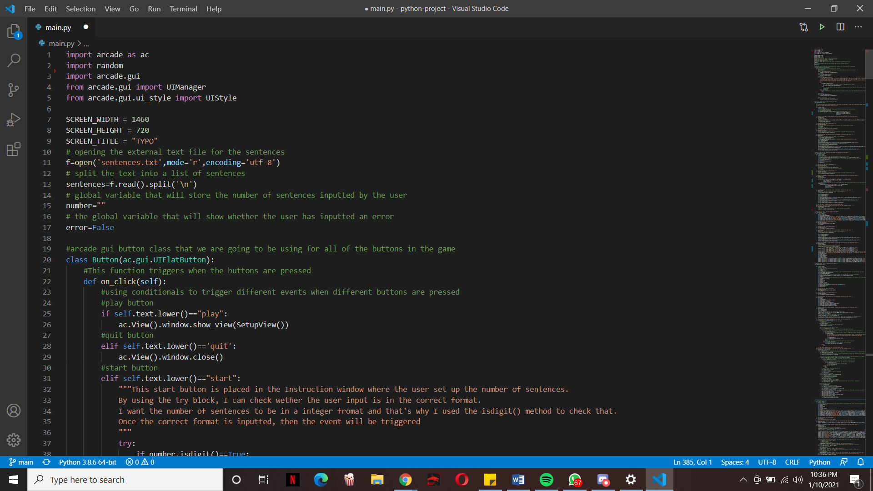

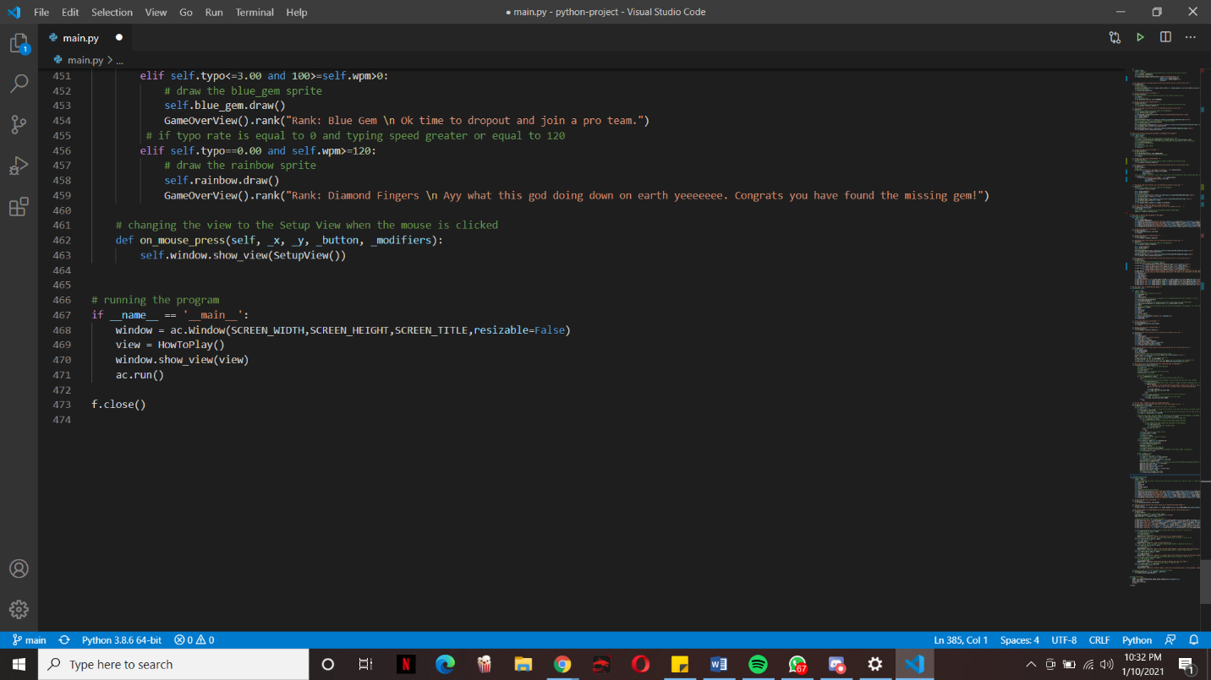

**Flowchart for the on_key_press for loop:**

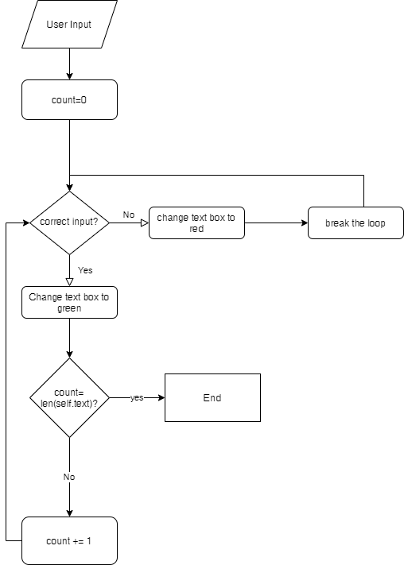

**Flowchart for the on_update for loop:**

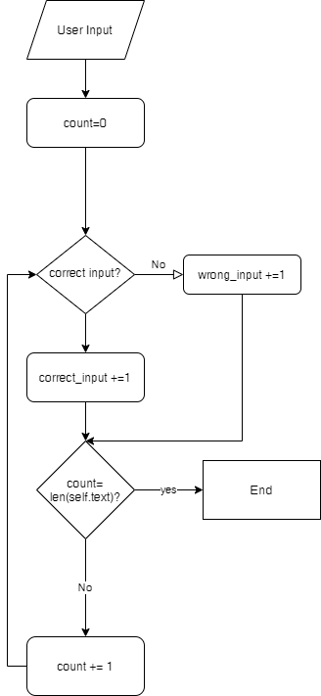

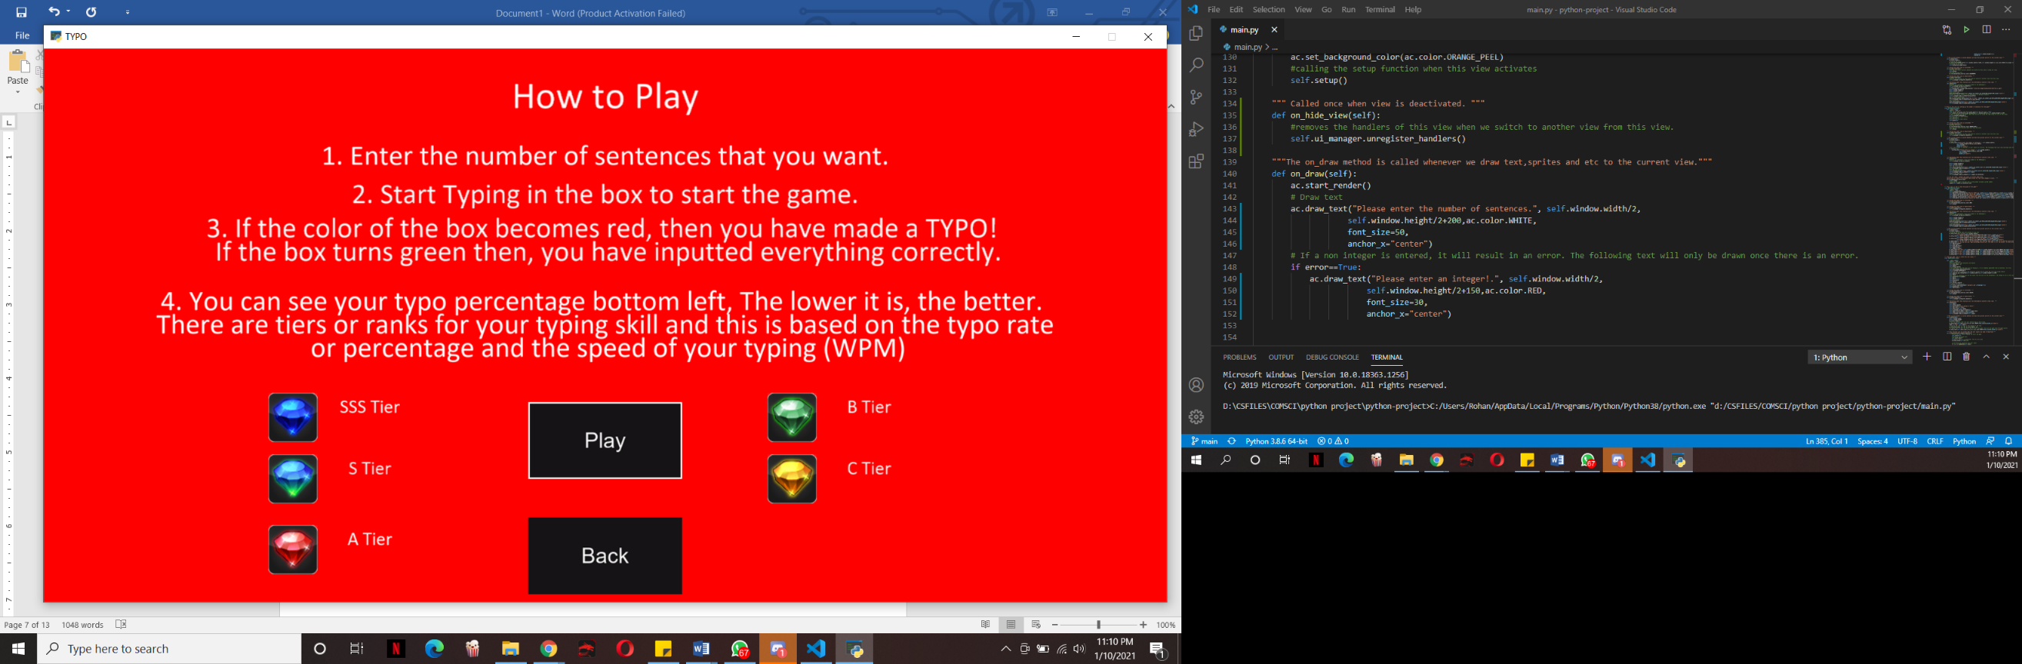**PROOF OF WORKING PROGRAM**

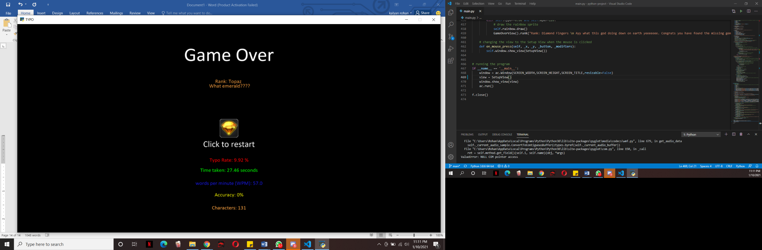

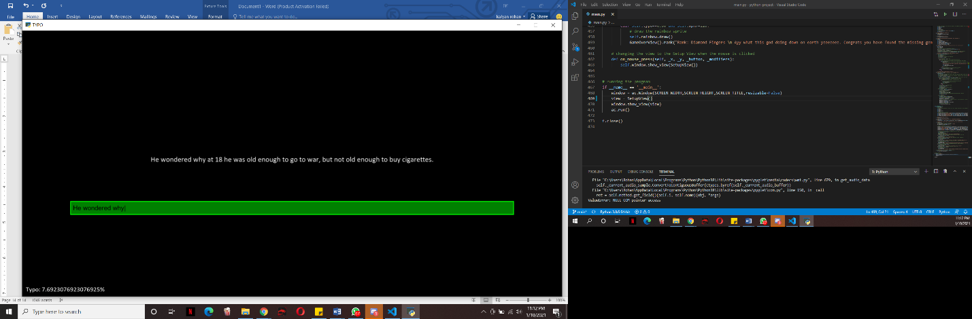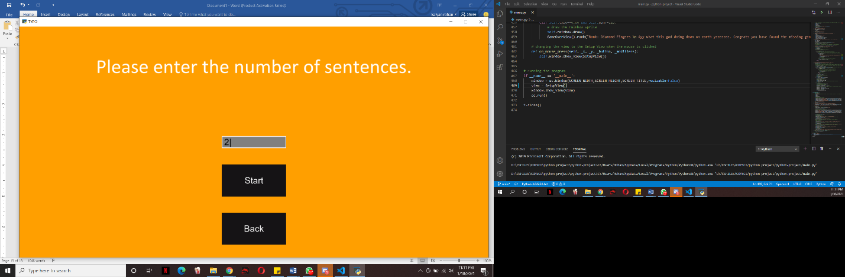

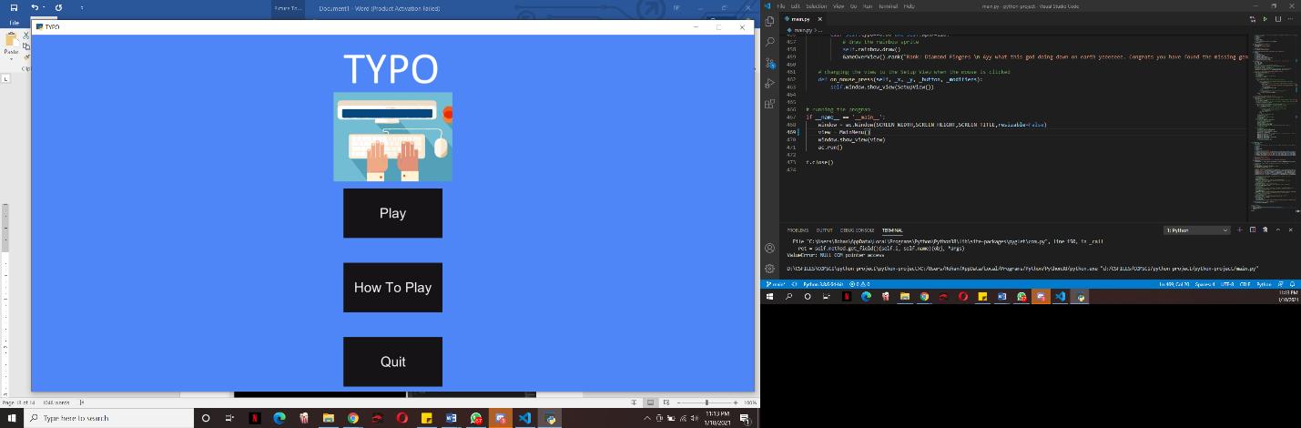

**References:**

<https://app.diagrams.net/>

<https://arcade.academy/>

<https://opengameart.org/content/basic-gems-icon-set>

<https://www.thewordfinder.com/random-sentence-generator/>

<https://www.fesliyanstudios.com/royalty-free-sound-effects-download/keyboard-typing-6>

<https://id.pinterest.com/pin/375206212681302825/>

<https://www.w3schools.com/>